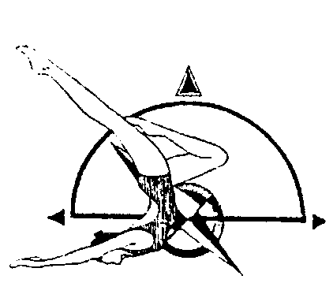
PNA Figures Invitational
UNITED STATES SYNCHRONIZED SWIMMING, INC.
Pacific Northwest Association

Novice, Intermediate, Age Group

May 1st, 2021
7:00 am – 11:00 am

MEET
The PNA Figures Invitational will be held in Newport Hills, Washington at the Newport Hills Swim and Tennis Club, It is governed by the 2021 USSS Rules and sanctioned by PNA.

FACILITY
Newport Hills Swim and Tennis Club
5464 119th Ave SE, Bellevue, WA 98006
425.746.9510

ELIGIBILITY All swimmers must be registered athletes with USSS for the 2020-2021 competition year. Canadian participants welcome as honorary.

REGISTRATION FORMS AND IMPORTANT DATES
Pre Meet Entry Form | N/A | coachdaniela@seattlesynchro.com
Registration Forms | April 15th, 2021 | olga.pastukhova1982@gmail.com  gretchen.house@philips.com
Fee Calculation Sheet & Payment | April 15th, 2021 | olga.pastukhova1982@gmail.com
Judges Availability Form | April 15th, 2021 | gretchen.house@philips.com
Coach Credential Form | April 15th, 2021 | coachkatleen@seattlesynchro.com

FEES
Sponsor Fee - $15 per competitor
Entry Fee - $10 per competitor per event

VOLUNTEERS

Please wear a white shirt and black bottoms.

FIGURE COMPETITION
Athletes wear black swimsuit and plain white caps. No logos on caps.

NOVICE
101 Ballet Leg Single 1.6
302 Blossom 1.4
361 Prawn 1.5
201 Dolphin 1.4

INTERMEDIATE
101 Ballet Leg Single 1.6
301 Barracuda 1.9
420 Walkover, Back 1.9
348 Tower 1.9

12 & UNDER AGE GRP
106 Straight Ballet Leg 1.6
301 Barracuda 1.9
226 Swam 2.1
363 Water Drop 1.5

13 – 15 AGE GRP
423 Ariana 2.2
143 Rio 3.1
355f Porpoise continuous spin 720 2.1
315 Seagull 2.1

COMPETITION SCHEDULE
A schedule will be available after all entries are received, entered and validated.

CONCESSIONS STAND
Each athlete must bring his or her snacks.

