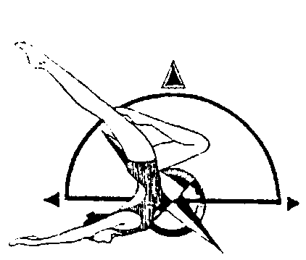
UNITED STATES SYNCHRONIZED SWIMMING,INC.
Pacific Northwest Association

Figures Invitational Meet & Grade Level Assessment

Novice, Intermediate, Age Group, Junior, Senior, Masters

Sunday January 10th, 2016

7:00 am – 2:00 pm

MEET
The Figures Invitational Meet & Grade Level Assessment will be held in Olympia, Washington at the Briggs YMCA Pool. It is governed by the 2016 USSS Rules and sanctioned by PNA.

FACILITY
Briggs YMCA Pool
1530 Yelm Highway SE
Olympia, WA 98501
(360)753-6576

HOTEL SUGGESTION
Information to come

ELIGIBILITY
All swimmers must be registered athletes with USSS for the 2015-2016 competition year. Canadian participants welcome as honorary.

REGISTRATION
Please complete both the Athlete Registration Form & the Judges Availability Form. Entries are due by 12/27/2015.

FEES
Sponsor Fee - $15 per competitor
Entry Fee - $10 per competitor per event

VOLUNTEERS

Please wear a white shirt and black bottoms for volunteer shifts.

FIGURE COMPETITION
Athletes – wear plain black one piece swimsuit & a plain white cap

NOVICE
101 Ballet Leg Single 1.6
310 Somersault Back Tuck 1.1

INTERMEDIATE B / 12 & UNDER AGE GRP
101 Ballet Leg Single 1.6
301 Barracuda 2.0
Figure 3
Figure 4

INTERMEDIATE A / 13 – 15 AGE GRP
423 Ariana 2.2
301 Barracuda Spinning 360 2.2
Figure 3
Figure 4

16 & Over AGE GRP
308 Barracuda Airborne Split 2.8
355 Porpoise Twist Spin 2.6
Figure 3
Figure 4

Note - Athletes will only compete in the two compulsory figures this meet. Second part of the meet will be used for a Grade Level Assessment. Athletes may want to bring a pair of tight fighting athletic shorts for the assessment.

**A Concession Stand will be provided by Olympia Synchro**

